MClust
Spike sorting toolbox

Documentation for version 3.5A
Released April 2008.

Original MClust by
- A. David Redish (ADR),
current address, University of Minnesota, Minneapolis MN.
Major modifications that have been incorporated into versions 3.0-3.5 were made by
- Neil Schmitzer-Torbert (NCST), University of Minnesota, Minneapolis MN.
- Jadin Jackson (JCJ), University of Minnesota, Minneapolis MN.
Modifications that have been incorporated into version 3.0 were made by
- Peter Lipa (PL), University of Arizona, Tucson AZ.
- Stephen Cowen (SLC), University of Arizona, Tucson AZ.
- Jadin Jackson (JCJ), University of Minnesota, Minneapolis MN.
- Francesco Battaglia (batta), University of Arizona, Tucson AZ.
BubbleClust (automated spike-sorter) was written by
- Peter Lipa, University of Arizona, Tucson AZ.
KlustaKwik (automated spike-sorter) was written by
- Ken Harris, Rutgers University, Newark NJ.

Changes made to version 3.5

Changes made to version 3.5B
- It turned out that the KlustaKwik import function was not correct when data had been split into subsampled files. I have fixed the save and import functions.

Changes made to version 3.5A
- I found that the version that only keeps currently visible feature data in memory is MUCH faster. I have thus returned MClust to use this method. Unfortunately, this makes version not backwards compatible with the previously released version MClust-3.5. [For programmers – I’ve done this using a global variable “MClust_FeatureSources” which tells MClust where to go to get the data. Feature functions are no longer assumed to return 4 features.]
- Time is now a real feature, and can be included or not.
- Minor changes: peak and time now deliver “_Peak” and “_Time” features so they always appear at the end of the list.
- Several bugs have been fixed in central code components that appeared in converting from mcclusters to and from mcconvexhulls.
- There is now a key to allow the application of mcconvexhulls from one data set to a new data set. To use this, load the new data set and then click the ApplyConvexHulls button.
- The “precut” cluster can now add and delete points. However, it remains just a list of points and cannot include limits or be applied to other data sets. The simplicity makes it fast for basic cutting.
- When adding clusters, there is a list-selection userinterface beneath the Add button that allows the user to add clusters of any type.

Changes affecting general users
- There is now a multistep undo/redo implemented as a pair of stacks. (Thanks JCJ!)
- A major change is that the manual cutter (MClustCutter) now handles multiple cluster types. Adding a new cluster type is relatively easy (see documentation below). All operations on cluster types are now modularized. There is now an important new concept, which is “convert cluster” that converts clusters between cluster types. Three cluster types are supplied with the base version of MClust-3.5:
@ precut – which allows no changes to the cluster as generated. This is the simplest cluster type.
@ mccluster – equivalent to the previous cluster type used in previous versions of MClust (3.0+). Allows adding points, adding boundaries, deleting points, etc.
@ mcconvexhull – equivalent to cluster types used in early versions of MClust (2.0). All points are specified by boundaries. Thus this cluster type can be saved and reloaded into a different data set.
- I have modularized as much as possible of the major options as well. Thus, for example ShowContourPlot is now a CutterOption like CheckAllClusters.
- ClusterSeparation is now included in the primary code set. Select CheckCluster from the cluster options or cutter options to see them.
- I have removed the BubbleClust pre-cutter option. Adding it back in should be relatively simple, but I do not use BubbleClust and can’t support it directly myself.
- ViewClusters has been removed as extraneous.
- Several changes have been made to the KlustaKwik decision decision window:
  - It can now export any of multiple cluster types (uses “convert cluster” to do so).
  - The correlation function is now controlled by the hold key. Any time a cluster is held, correlations are shown.
  - The correlation function is correlation over all valid channels. (Thanks NCST!)
  - The window now allows keyboard control of simple components: (up/down arrow moves selected cluster up/down, pgup/pgdn moves the set of visible clusters up/down, “k” turns the keep on/off). For other functions, a mouse is still necessary.

Changes affecting programmers
- Changed name of "generalizedcutter" to "MClustCutter".
- Renamed “mcconvexhull” to “mccluster”. I have added a new “mcconvexhull” cluster type which should enable saving and loading pure boundaries. This should enable applying bounds to new data sets.
- In the new cluster types, any function starting with “CTO_” will be listed in the cluster function availabilities. Thus, “CTO_AddPoints” is listed as “AddPoints”. This makes cluster functions completely modular.
- RunWaveFormCutter: a cluster type needs to include "Restrict_Points" as a method in order to use WaveformCutter. Thus the only cluster type currently supporting the wave form cutter is @mccluster.
- Both ClusterOptions and general options (MClustCutterOptions) must now return [redraw, rekey, undoable] which controls whether the 2D drawing axis is redrawn, whether the clusters list is remade, and whether the undo state is stored. If the cluster option changes the cluster itself, make sure it changes the global MClust_Clusters.

Changes affecting central code components
- Previous versions had been written so that only the currently visible feature data was kept in memory. With larger memory spaces available in current machines, we have returned to the simpler method which keeps all feature data in memory.
- .cut files are no longer written as they were deemed unnecessary.

Spike sorting
Neurophysiological recordings usually include spikes occurring on multiple cells simultaneously. It is important to be able to separate the spike trains of each of these cells. Because spikes occurring on different cells should show different waveform parameters (peak height, total energy, waveform shape, etc.), the spikes from a single cell will form clusters in that high-dimensional space (McNaughton, O’Keefe, and Barnes, 1983, J. Neurosci. Methods, 8:391–7; Fee, Mitra, and Kleinfeld, 1996, J. Neurosci. Methods, 76:3823–31). Tetrodes and stereotrodes have also proven useful for differentiating spikes from multiple cells: different cells show different spike shapes on each channel of the tetrode or stereotrode (McNaughton, O’Keefe, and Barnes, 1983, Wilson and McNaughton, 1993, Science, 261:1055–8). Many advances have been made in spike sorting in the last decade. There is not room to list those advances here. Where specific citations have been incorporated into MClust, those citations are noted in the text.
MClust is a toolbox which enables a user to perform automated and manual clustering on single-electrode, stereotrode, and tetrode recordings. It allows manual corrections to automated clustering results. It outputs t-files, which contain (after a header) a list of timestamps in binary format. Timestamps are 32-bit longs at a resolution of 10 timestamps/ms.

Requirements
MClust is written in Matlab™ (The MathWorks Inc., Natick MA) and requires Matlab™ version 2007a or higher. MClust-3.5 has been tested on PC workstations running the Windows (Microsoft Corp.) family of operating systems. It should, however, be portable to any system capable of running Matlab™ with an ANSI-compatible C++ compiler.
New components added in version 3.5 require toolboxes. If you do not have these toolboxes, you can still use MClust, but will not have the complete functionality. Specifically, the Statistics toolbox is needed for measuring Cluster Separation (see below), while the Signal Processing toolbox is needed for smoothing the contour map. Warnings are given if the toolboxes are unavailable. These warnings can be suppressed with “warning off MCLUST:ToolboxUnavailable”.

Disclaimer
This code is copyright © by the original authors (see above), 1998-2003.
None of the authors, nor their respective labs, nor their respective universities, assume any liabilities for this code. Use at your own risk. We have done our best to ensure that this code is correct, but do not make any guarantees. This program is distributed in the hope that it will be useful, but without any warranty; without even the implied warranty of merchantability or fitness for a particular purpose.
Use of this code should be acknowledged in any paper that uses data analyzed with it. Acknowledgement should be in the methods section as “(MClust-3.5, A. D. Redish et al)”. Use of automated cutters should be acknowledged as “BubbleClust (P. Lipa)” or “KlustaKwik (K. Harris)”.
This code may be distributed freely. However, all distributed copies must include all components included in the original distribution. This code may not be modified without the express written consent of the author (contact A.D. Redish for permission).
[However, MClust is designed to facilitate the incorporation of new loading engines, new features and new cutting methods. If you have such that you wish to include, please contact me. - adr]
Send bug reports, questions, and comments to redish@umn.edu. Please do not send emails related to MClust to any of the other authors. None of the authors, nor their respective labs, nor their respective universities assume any responsibility for replying to such email, to fixing said bug-reports, or to maintaining this code. This code is distributed as is. [However, I will reply if I have time. I will do my best to fix bugs, answer questions, incorporate new features and cutters, etc. Many of the updates to this version were done by others, see above. - adr]

Installing MClust
This assumes that you have already installed Matlab on your computer.
- Create an MClust directory in the Matlab™ hierarchy.
- Unzip the archive (MClust-3.3.zip) into the new MClust directory.
- Add the MClust directory to your Matlab™ path (see Matlab™ information for how to do this).
- Start up Matlab™ and type MClust and you’re off…

Components

Loading Engines
In MClust-3.0, we have split out the loading engine. Any .dll or .m file placed in the LoadingEngines directory will be declared a plausible loading engine. In the Mclust main window (Figure 1), there is a pop-up menu to select the loading engine.

Loading engine requirements
A loading engine must be callable as a Matlab function. This means it must be either a .m function-file or a compiled mex function-file. It must take as input one or three inputs and provide one or two outputs. MClust-3.0 should work with any loading engine that supplies this functionality.

INPUTS
- fn = file name string
- records_to_get = a range of values
- record_units = a flag taking one of 5 cases (1,2,3,4 or 5)
- implies that records_to_get is a timestamp list.
- implies that records_to_get is a record number list
- implies that records_to_get is range of timestamps (a vector with 2 elements: a start and an end timestamp)
- implies that records_to_get is a range of records (a vector with 2 elements: a start and an end record number)
- asks to return the count of spikes (records_to_get should be [] in this case)
In addition, if only fn is passed in then the entire file should be read.

OUTPUT
- [t, wv]
- t = n x 1: timestamps of each spike in file
- wv = n x 4 x 32 waveforms

EXAMPLES
- [t,wv] = myLoadingEngine(‘myfile.dat’, 1:10, 2) should return the time and waveforms for the first 10 spikes in the file.
- t = myLoadingEngine(‘myfile.dat’) should return all the timestamps from the file.
- n = myLoadingEngine(‘myfile.dat’, [], 5) should return the number of spikes in the file.

Features
Features are processed parameters of spikes. Most features produce one number for each valid channel for each spike.

Currently available features
energy — the energy contained within the waveform of each channel of the spike. Also known as the L2 norm. Produces one parameter for each valid channel. In the cutter, this feature will appear as energy: Ch.
peak — the maximum height of the waveform of each channel of the spike. Produces one parameter for each valid channel. In the cutter, this feature will appear as peak: Ch.
time – the time of each spike.
wavePC1,2 — Returns for each waveform the contribution to the waveform that is due to the first (wavePC1) or second (wavePC2) principal component . In the cutter, this feature will appear as wavePC1(or 2): Ch.

Extra Features
The following features are in the “Extra Features” directory. To add them to your feature list, copy them into the Features directory under MClust.
area — the area within the waveform of each channel of the spike. Area is defined as the integral of the positive component relative to zero plus the integral of the negative component relative to zero. Also known as the L1 norm. Produces one parameter for each valid channel. In the cutter, this feature will appear as area: Ch.
valley — the maximum depth of the waveform of each channel of the spike. Produces one parameter for each valid channel. In the cutter, this feature will appear as Valley: Ch.
peakValleyRatio — the ratio between the peak and valley parameters. Produces one parameter for each valid channel. In the cutter, this feature will appear as peakValleyRatio: Ch.
spikeWidth — the width of each channel of each spike. Width is defined as the position (out of 32 samples) of the peak minus the position (out of 32 samples) of the valley. Thus spikeWidth can be negative. Since spikeWidth is integral, a small random value (±0.5) has been added to spikewidth to provide for scatter. This provides a better visual picture without changing the integrity of the spikeWidth parameter. In the cutter, this feature will appear as spikeWidth: Ch.
peakIndex — the sample at which the peak occurs in each spike; defined as the position (out of 32 samples) of the peak. Since peakIndex is integral, a small random value (±0.5) has been added to spikewidth to provide for scatter. This provides a better visual picture without changing the integrity of the peakIndex parameter. In the cutter, this feature will appear as peakIndex: Ch.
peak6to11 — the maximum height of the waveform of each channel of the spike in samples 6 to 11 of the wave form. Produces one parameter for each valid channel. In the cutter, this feature will appear as peak6to11: Ch.

Adding new features
Any Matlab function that is named “Feature_XXX.m” or “Feature_XXX.dll” and is placed in the Features directory will be included as a possible feature with the name XXX. Features must take as input three parameters and return as output three parameters. MClust-3.0 should work with any loading engine that supplies this functionality.

INPUT
- V = A tsd of tetrode data (time = n x 1 array of times, data = n x 4 x 32 array of waveforms)
- ttChannelValidity = nCh x 1 of Booleans
- Parameters = a cell array of internal information

OUTPUT
- FData = feature-calculated data (nSpikes x number of valid channels)
- FNames = a cell array of names (one for each valid channel)
- Parameters = a cell array of internal information. If the feature needs to be stopped and recalled, it will be repassed into the function as Parameters.

Manual cutting
- Start Matlab™.
- Type MClust at the prompt. This will open the main MClust window (Figure 1).
- Select which features you wish to use to cluster the spikes. Features are moved between the IgnoreFeature and UseFeature lists by clicking on them.
- Select the file to cut (you can select either the original data file or any feature data file from this file).
- Click on ManualCut: Convex Hulls. This will open the Cluster Cutting Control Window (Figure 4).
- Cut your clusters.
  - Click on Redraw Axes to open the Cutting Window.
  - To add a cluster, select the Add Cluster button. When a cluster is added, it contains no boundaries.
  - To add a boundary, under the functions selection menu for that cluster, select Add points. This will transfer the cursor to the cutting window. Select a set of points by clicking with the left button of the mouse. When you have selected the points, hit the enter key on your keyboard. For speed purposes, points are not drawn on the cutting window online. After hitting the enter key, the a boundary should appear. The boundary used is the convex hull of the points you selected. All spikes that fall within the boundary will change color to match that of the cluster, indicating that these spikes are now within that cluster. To add boundaries on other dimensions, change the axes drawn and add more limits. Spikes within a cluster are defined as those that fall within all of the boundaries defined for that cluster.
  - Continue adding clusters and boundaries (add boundaries with either inclusive or restrictive limits) until you are satisfied with the clusters. See below for additional features which allow deleting boundaries, copying clusters, merging clusters, checking cluster parameters, etc.
  - When you are done cutting clusters, exit the Cluster Cutting Control Window.
- Click on Write Files to save the processed clusters.
- Exit MClust.

Cutting clusters with convex hulls
The cluster cutting engine consists of up to three windows (Figure 5). When the cutting engine starts up only the control window will be visible. To create a cutting window, click on Redraw Axes. Whenever the Redraw Axes checkbox is checked, any changes will be immediately shown in the cutting window. Unchecking and rechecking the Redraw Axes checkbox will redraw the cutting window.
Which 2D projection will be shown in the cutting window is controlled by the two selection boxes in the upper left corner of the control window. The arrows immediately below, steps through the possible projections. View all dimensions quickly steps through the projections.
Clusters are objects which define regions of the high-dimensional space. When the control window first opens, there will be no cutting clusters shown; only the zero cluster will be shown. The zero cluster is the set of all points. To add a cluster, select the Add Cluster button. Add clusters as necessary. Up to 99 clusters can be added.
When a cluster is added, it contains no boundaries. To add a boundary, under the functions selection menu for that cluster, select Add limit. This will transfer the cursor to the cutting window. Select a set of points by clicking with the left button of the mouse. When you have selected the points, hit the enter key on your keyboard. For speed purposes, points are not drawn on the cutting window online. After hitting the enter key, the a boundary should appear. The boundary used is the convex hull of the points you selected. All spikes that fall within the boundary will change color to match that of the cluster, indicating that these spikes are now within that cluster. To add boundaries on other dimensions, change the axes drawn and add more limits. Spikes within a cluster are defined as those that fall within all of the boundaries defined for that cluster.
You can exit and re-enter the cutting engine as many times as you want.

Add points vs. Add limit
@mccluster type clusters in MClust 3.5 work by defining a set of points considered to be members of the cluster (using Add points), and refining that set of points by eliminating some of these cluster (using Add limit). Thus, the current members of a cluster are defined by the set of points that have been added that fall within the boundaries defined by the limits.

Splitting a cluster
If you have a cluster that you wish to split into two clusters, copy the cluster and add new restrictive boundaries.

Additional cluster features
Changing cluster color — Clicking on the color box next to the cluster will pop up a color control window allowing you to change the color used for the cluster. This color will be used for both boundaries and spikes falling within the cluster.
Check cluster — Shows key parameters for the cluster. Average waveform, ISI histogram, etc. See Figure 6.
Delete limit — In the functions menu for each cluster, Delete limit removes the boundary for that cluster on the currently shown projection.
Delete all limits — In the functions menu for each cluster, Delete all limits removes all boundaries for that cluster.
Delete all points — Clusters created with KlustaKwik and BubbleClust do not have limits and must be deleted with DeleteCluster.
Copy cluster — In the functions menu for each cluster, Copy cluster creates a new cluster with the same boundaries as the cluster in question.
Merge with — In the functions menu for each cluster, Merge with asks for a cluster number and then creates a new cluster in which the boundaries are the convex hull of all the boundaries for the two clusters.
Hiding clusters — When the Hide checkbox next to a cluster is checked, no boundaries or spikes falling within that cluster will be drawn on the cutting window. The Hide and Show buttons on the left panel of the control window, hide or show all the clusters.
Pack clusters — Selecting the pack clusters button, removes all clusters that contain no spikes. Other clusters are moved up the list to fill the blank spaces.
Undo — MClust-3.5 has a ten-step undo.

Final checks
After clusters have been cut, the clusters can be checked for key parameters using the following two buttons.
CheckAllClusters — Shows key parameters for each cluster currently defined (average waveform, interspike interval histogram, etc.).
EvalOverlap — Counts the number of spikes in each pair of currently defined clusters. The Eval overlap button pops up a window but also writes the table of overlaps to the Matlab™ control window. The formatting on the window can be misaligned, but the text output will always be correct.

Cluster Separation
At a dinner meeting organized by Cliff Kentros at SFN*2002, it was noted that there was no standard technique for measuring recording quality with multi-channel electrodes (such as stereotrodes and tetrodes). At that meeting, it was noted that a measure of cluster separation would go a long way towards providing those quality measurements. MClust-3.3 includes two measures isolation distance (developed by KD Harris et al. Neuron, 32:141, 2001) and L-ratio (developed by NC Schmitzer-Torbert et al. submitted-a). Both measures assume that the cluster forms a multi-dimensional Gaussian in feature space. Isolation distance measures how many sigma one has to go to double the number of points in the cluster. L-ratio measures the number of extra-cluster points, weighted by the expected χ² distribution expected from the Gaussian shaped cluster.
We have submitted a paper detailing these two measures and their respective properties (NC Schmitzer-Torbert et al. 2005). People wishing to report cluster separation values from MClust should cite this paper.

ClusterOptions
Under the MClust directory is a ClusterOptions directory. Under the ClusterOptions directory is an Extras directory. To use these options, move the file up from the Extras directory into the ClusterOptions directory. To remove these options, move the file back down.
These files will be visible in the functions list for each cluster. These include AverageWaveform, ISI histograms, etc.
Note: Any file that appears in the ClusterOptions directory will be available in the functions list for each cluster. Any file that takes as its sole input a cluster index (i.e. which cluster called it) and has no outputs can be used as an additional cluster option.

MClustCutterOptions
Under the MClust directory is a MClustCutterOptions directory. Any file that appears in the MClustCutterOptions directory will be available in the functions list for each cluster. Any file that takes no imputs and has no outputs can be used as an additional option.

Autosave
MClust keeps track every time a change is made to the defined clusters. After 10 steps, it automatically saves the current clusters and the current defaults. The current clusters are saved in autosave.clusters and the current defaults are saved in autodflts.mclust. Clicking on the Autosave button forces an immediate autosave.

Cluster Types [New in MClust 3.5]
A new change that has been made in MClust 3.5 is that cluster types have been brought out to be a full part of the modularity of the ManualCutter. Each cluster is a member of a cluster type (a class). Any mclust class (a directory starting with “@”) placed under the ClusterTypes directory will be available as a cluster.
A valid MClust cluster type must provide the following
- It must have a field “name”. This will be accessed directly and must be available.
- It must provide a constructor that can take 1, or 2 inputs. With 1 input, it must create an empty cluster with the name as the input. With 2 inputs, it must create a cluster with name derived from the first input and taking points (as it pleases) from the second.
- It must provide a method [f, MCC] = FindInCluster(MCC), which returns a list of points in the cluster MCC.
- It must provide a method [msg] = GetInfo(MCC), which returns a cell-array of strings for a message providing “information about the cluster”.
- It must provide a method [name] = GetName(MCC), which returns the name of the cluster.
- It must provide a method [MCC] = SetName(MCC, name), which changes the name of the cluster.
A valid cluster type may also (but does not have to) provide the following
- If it provides DrawOnAxis(MCC, xdim, ydim, color, axisHandle), that will be called when the cluster is not hidden and the drawing axis is available.
- If it provides MCC = Restrict_Points(MCC,idx), it will be able to work with the WaveformCutter, which will call Restrict_Points with the points to get rid of.
Finally, any functions in the class that start with CTO_ will be included as available functions for that cluster. These functions must return [MCC, redraw, rekey, undoable]. These functions are always called with the cluster as the first argument, and a list of argument pairs in the varargin set. Returning true for redraw makes the axes redraw; rekey recreates the cluster list; undoable stores the undo state from before the function was created. MClustCutterCallbacks currently provides the following list via varargin:
- 'iClust', iClust – the cluster number (in the global variable MClust_Clusters)
- 'figHandle', figHandle – the handle for the Cutting Figure
- 'xdim', xdim – the x dimension being plotted
- 'ydim', ydim – the y dimension being plotted
- 'drawingAxis', drawingAxisHandle – the drawing axis if available
Examples provided in the mccluster class include
- [MCC, redraw, rekey, undoable] = CTO_MergeWith(MCC, varargin)
- [MCC, redraw, rekey, undoable] = DeletePoints(MCC, varargin)
- [MCC, redraw, rekey, undoable] = CTO_Delete_AllLimits(MCC, varargin)
- [MCC, redraw, rekey, undoable] = CTO_02_Delete_Limit(MCC, varargin)
and others.

Automated cutting with manual touch-up
MClust-3.5 includes an automated spike-separation algorithms KlustaKwik. Both algorithms find clusters of points in a high-dimensional space. Because they work in all dimensions simultaneously, they tend to separate noise and real spikes better than manual cutting. However, both algorithms can also miss entire clusters as well as incorrectly merging two clusters. Therefore MClust-3.5 offers the user the chance to touch-up and correct the automated algorithms.
KlustaKwik performs an expectation-maximization fit of n Gaussians to the data. This creates a set of putative clusters. As noted above, KlustaKwik will often split a single cell’s data into multiple clusters and may sometimes merge two clusters that are in fact separate cells. These can be corrected in the KlustaKwikDecisionWindow.
The two algorithms are slightly different, but their role in MClust is similar. Both BubbleClust and KlustaKwik are EXE programs which, once compiled run outside of Matlab. First, you must run the programs (the best way is with the batch-processing supplied with MClust-3.5, this can be done off-line without user interaction). Then the data is read in and the user selects/corrects the cut. Finally, the clusters are exported into the manual cutting system for further touch-up and write-out.
Batch Processing
MClust 3.0 supplies a program (RunClustBatch.m) that allows the user to apply BubbleClust.exe or KlustaKwik.exe to data files. The output of these programs can then be viewed and refined using MClust 3.0.
Using RunClustBatch.m, the user can generate clusters using BubbleClust or KlustaKwik. RunClustBatch loads settings from a batch file and then runs the automated clustering program. Default batch files are included in the MClust\Batch directory; Batch_KlustaKwik.txt contains settings for running KlustaKwik, and Batch_BBClust.txt contains settings for running BubbleClust. See below for a description of the batch file fields.
BubbleClust and KlustaKwik are not able to process unlimited numbers of spikes. Capacity depends on both the number of spikes and the number of features by number of valid channels. With 12 dimensions (3 features with 4 valid channels), BubbleClust on our machines can process files of up to 350,000 spikes, and KlustaKwik can process files of up to 1.3 million spikes (the largest that we have tested it with). If larger files are to be processed, the feature data files need to be split into a number of smaller pieces.
RunClustBatch uses a variable, SubSampleToNSpikes (see description below below) to identify the maximum number of spikes to send to the clustering program (BubbleClust or KlustaKwik). If this threshold is exceeded, RunClust batch will split the feature data files into multiple files whose size will be no larger than the value of SubSampleToNSpikes.
To use RunClustBatch,
- Copy the appropriate default batch file (Batch_KlustKwik.txt or Batch_BBClust.txt) to the directory containing the data files which are to be processed.
- Rename the batch file copy Batch.txt.
- Start up Matlab, and move to the directory containing the data files to be processed.
- Type RunClustBatch.
RunClustBatch will generate feature data files for each of the features specified in the batch file. The default location for these files is in a directory, FD, which is a subdirectory in the directory containing the data that is being processed. MClust3.0 assumes that feature data files are either in this subdirectory, or in the same directory as the data files.

Batch file fields
ProcessingDirectory — Directory containing the data to process. Usually the current directory.
FeatureDataDir — Directory to place the feature data files that are created in running RunClustBatch.
FindFilesSearchString — A string used to search the processing directory for files to process. (Example, TT*.dat)
AddToBatchList — A space separated list of other files to add to the list of files to process. (Example, TT1.dat TT2.dat TT3.dat). Useful if you only want to process a few files in a directory.
RemoveFromBatchList — Files to remove from the list of files to process. Useful to remove files which do not contain any spikes.
ClusterAlgorithm — BBClust or KlustaKwik
LoadingEngine — Specifies the loading engine to use.
UseFeatures — Features to use in clustering, generally we use energy, wavePC1, wavePC2 and sometimes waveFFT.
ExtraFeatures — Other features which will be calculated, but not used for clustering. These are features you can calculate during the call to runclustbatch to save yourself time when loading files into MClust, because they will already be finished.
ChannelValidity — What channels to use in calculating feature data files.
SubSampleToNSpikes — Threshold for splitting feature data files. If files are too large, MatLab won't be able to load all of the spikes into memory at one time. Also, BubbleClust will choke if too many spikes or features are sent to it. On our machines, 350,000 is a good value for BubbleClust, and 2,000,000 is a good value for KlustaKwik. BubbleClust, in our experience, is slow for files approaching 350,000 spikes.
NumberOfNearestNeighbors — number of nearest neighbors to use with BubbleClust
KKwik_MinClusters — Minimum number of clusters to initialize KlustaKwik with. For more information, see original documentation of KlustaKwik.exe
KKwik_MaxClusters — Maximum number of clusters to initialize KlustaKwik with.

Using KlustaKwik output
Once KlustaKwik has been run on a data file, the generated clusters can be imported into MClust3.5.
- Start Matlab™.
- Type MClust at the prompt. This will open the main MClust window (Figure 1).
- Select which features you wish to use to cluster the spikes. Features are moved between the IgnoreFeature and UseFeature lists by clicking on them.
- Select the file to cut.
- Click on KlustaKwik Selection. This will open a decision window for viewing the automatic clustering output.
[changed 3.5B] KlustaKwik will ask you to identify the .clu file if there is more than one that identifies with your original data. If you have split your data to speed up KlustaKwik, then each split file will be identified with a clu.X number where X is the number of the subset. You should load each file separately into a KlustaKwik decision window and go through the normal identification processes. (Do one at a time.) When you are done, export them into the main manual clustering window and then go on to the next one. When you have done all of them, then you can merge cells between subsampled sections.
KlustaKwik Decision Window
The general purpose of the KlustaKwik Decsion Window is to allow the user to examine the KlustaKwik clusters and select 1) which clusters are likely to be cells, and 2) which clusters result from the splitting of a single cell and need to be merged. Clusters can be either merged in the Cluster Cutting Window, or they can be merged on export to MClust.
Plotting: If the View2D, View3D or Contour boxes are checked, these plots will be updated anytime a relevant change is made. When checked, the current cluster is always shown, as is the held cluster, if there is one. If show all points is checked, all of the points will be shown in black, and if show keeps is checked, then the keeps will be shown as well.
Window Options
Selecting a cluster: By clicking on the cluster number (to the right of the colored box), the cluster can be selected and will change color to cyan. The text in the CURRENT CLUSTER box will be changed to that of the selected cluster, and the waveform and histISI will be shown below in blue (The waveform on invalid channels will be shown, but plotted in black).
X,Y and Z axis — Shows which features are plotted on each axis.
View 2D — Shows a two-dimensional plot of Y by X
View 3D — Shows a three-dimensional plot of X, Y and Z.
Contour — Shows a contour plot of the density of points of the current x and y axis selections.
Correlation — Shows the correlation of the waveform of the current cluster with the waveform of each other cluster and displays the correlation coefficients to the right of the cluster number. Correlation is based on the waveforms from all valid channels. Useful for identifying which clusters likely are from the same cell.
Export all Clusters — Loads the Cluster Cutting Control Window and creates one cluster for each cluster which has been checked in its keeps box in the KlustaKwik Decision Window.
Export with Color Merge — Loads the Cluster Cutting Control Window and creates one cluster for each set of keeps sharing the same color. If several clusters are judged to be the same cell and all are set to the same color, these clusters will be automatically merged into a single cluster. This saves the user a step after loading the Cluster Cutting Control Window and decreases the number of clusters to sort through in the cutting window.
Exit — Closes the KlustKwik Decision Window. Does not save any of the keeps, or colors which have been selected for the Klusta Kwik Clusters.
Cluster options
Hold — Show the waveform and ISI of this cluster in red. Used to identify which clusters are identical to other clusters and should be merged.
Keep — Select this cluster to be exported to MClust when an Export option is chosen.
Selecting a color: Click on the colored box next to the cluster number. A palette of colors will be shown. Click on one and select ok to change the color of the cluster. Choose cancel to leave the color unchanged.

Write files
When done cutting clusters, select Write Files to output the processed data. MClust writes out three file types.
.t files — Each cluster generates a corresponding .t file. This file contains a header (beginning with %%BEGINHEADER and ending with %%ENDHEADER) and then consists of a list of timestamps. These timestamps are the times at which the spikes in the cluster occurred. The file format for .t files is in binary.
.cluster files — Each input file generates a single .cluster file. This file is a Matlab binary file containing the cluster objects themselves.

Additional features

Loading and saving defaults
The defaults.mclust file contains information for the way MClust looks. It saves the color scheme used for the clusters, the features used versus features ignored, the channel validity, and the loading engine.
Autosave saves the current default settings in autodflts.mclust. These can be loaded using the Load defaults button.
When MClust starts up it looks first for defaults.mclust in the current directory, then in the MClust directory.

Loading, saving, clearing clusters
Clusters can also be loaded and saved separately. When loading clusters, the features used and the channel validity must be identical to when they were saved. Write Files saves clusters automatically.
Clearing clusters deletes all limits and packs the clusters. There is no undo for clearing clusters.

Clearing the workspace
A button is supplied which clears all of the global variables used by MClust-3.0. Clicking this button is equivalent to exiting and restarting Matlab. It is recommended that the user click this button between cutting different data files (e.g., different tetrodes).

Cutting non-tetrode data
Some people have used MClust to do spike sorting on single-electrode (SE) and stereotrode (ST) data. It should work on those data as well. In order to load SE or ST data, the user must (1) use an appropriate loading engine and (2) turn off the channel validity for channels 2, 3, & 4 (for SE) or 3 & 4 (for ST). Selecting an SE or ST loading engine does not automatically affect the channel validity.
A loading engine which loads SE or ST data must pad the waveforms with 0’s to fill out four channels. [We are looking into the possibility of making the code compatible with different size waveform matrices, but it turns out to be more complex than we hoped. – adr]

FAQ (Troubleshooting / Warnings / Issues)

Other platforms
“I have LINUX on my PC. Can I still run MClust?”
MClust has only been tested on PCs running the Windows family of operating systems. However, it should run on any machine that can run Matlab and has an ANSI-compatible C++ compiler. If you want to try porting MClust to another platform, contact me at “redish@umn.edu” and I will do my best to help you.

Matlab™ licenses
“Do I have to have Matlab™ to run MClust?”
Yes. MClust runs within the Matlab architecture. Therefore you will need to have Matlab to run MClust.
As noted above, some functionality requires toolbox licenses as well. If you do not have those toolboxes, MClust will still work and will still be able to cut clusters.

Example screen-shots

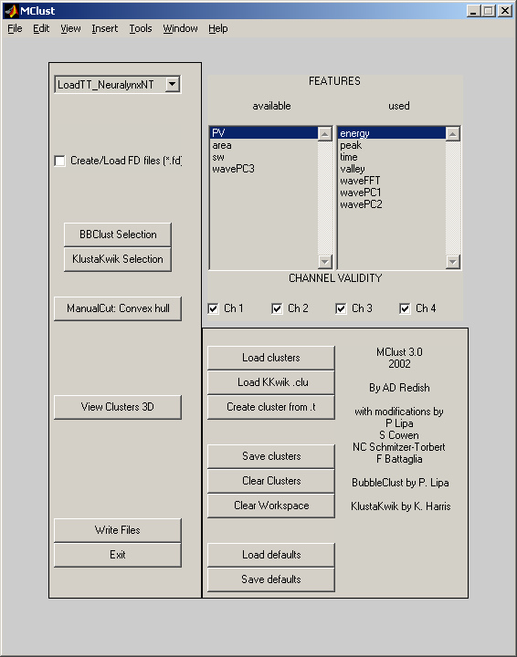

Figure 1: The main MClust window.
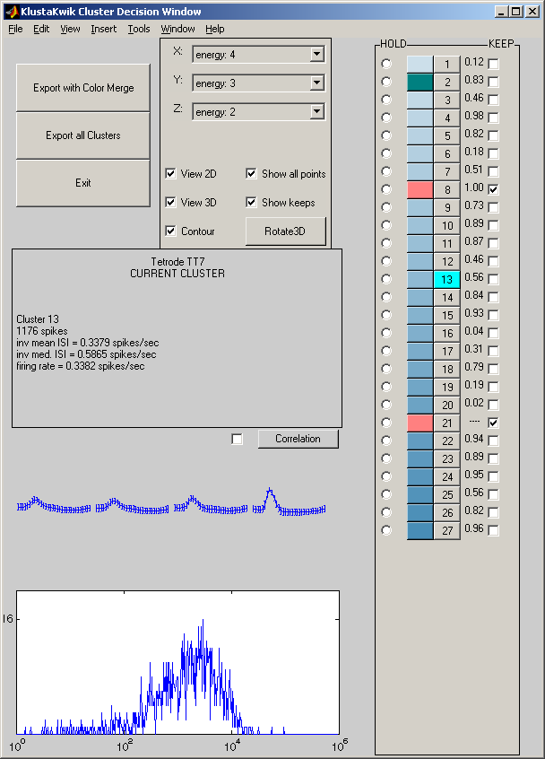

Figure 2: The KlustaKwik Decision window.
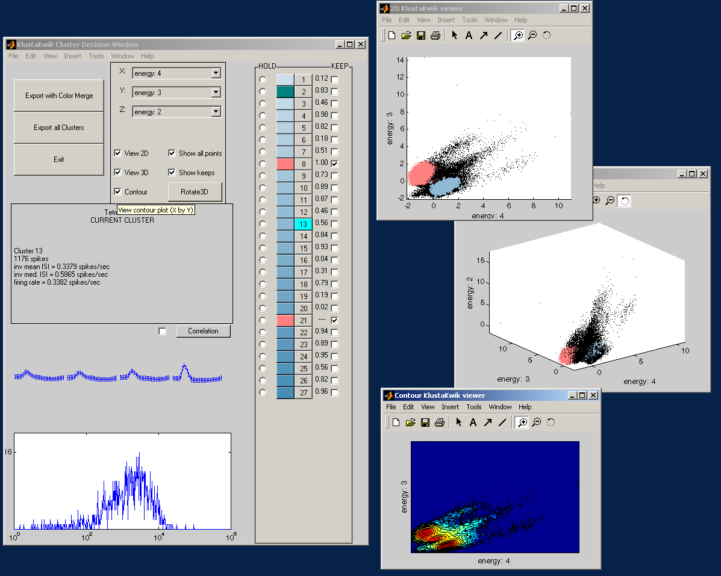
Figure 3: A KlustaKwik Selection session.
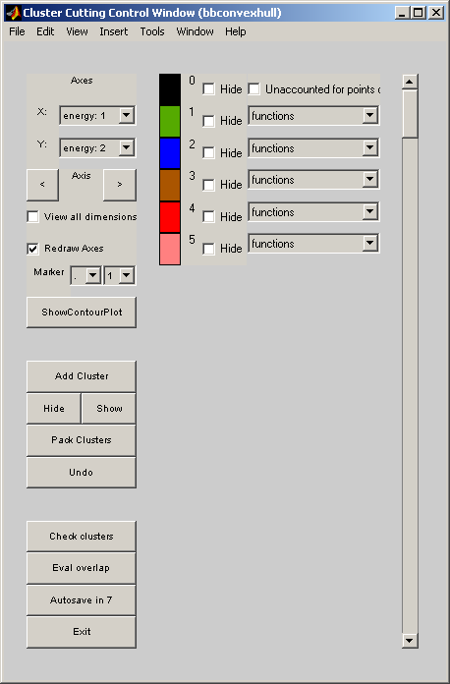

Figure 4: The Cluster Cutting Control Window.

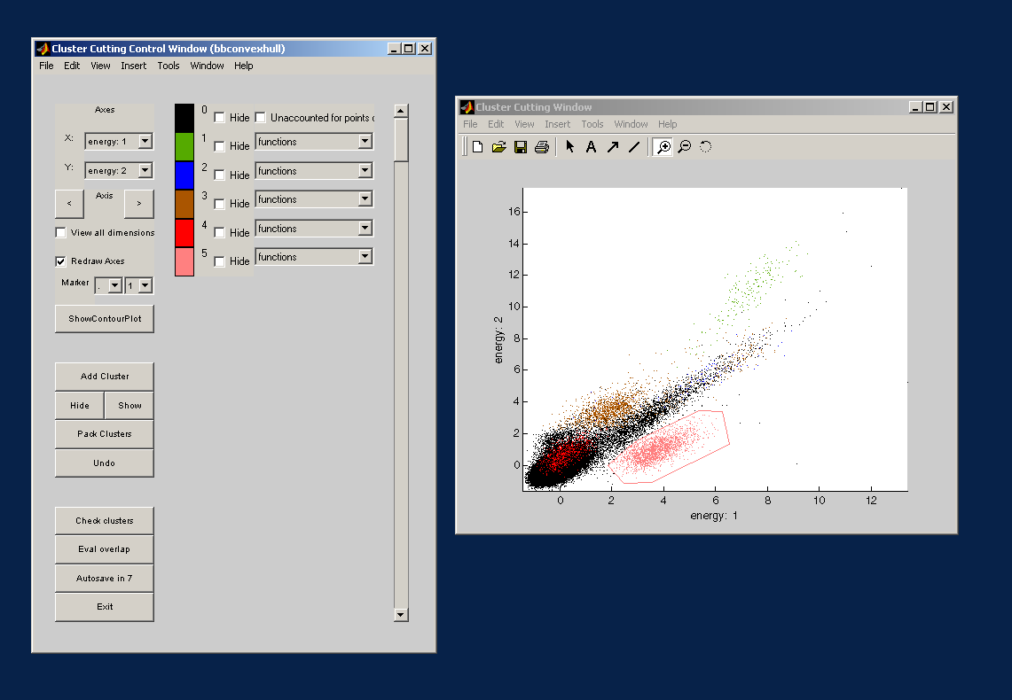
Figure 5: A Cluster Cutting Session.
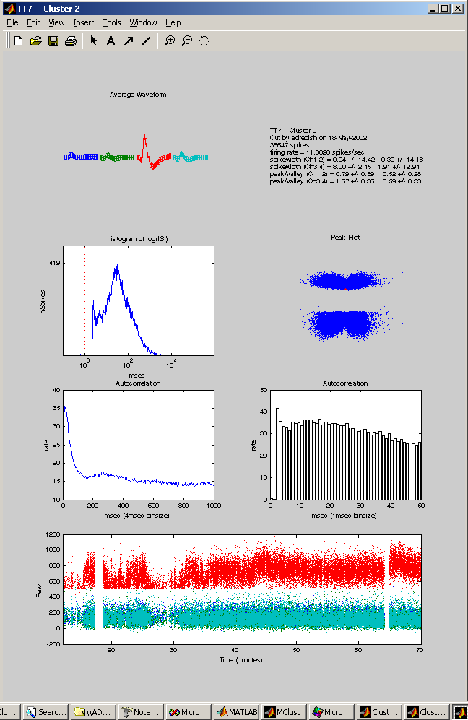

Figure 6: A CheckCluster window.

